Mighty Adventure Camp –
Common Questions

Q- What hours does Adventure Camp run from?
- Drop Off is from 8-830AM and Pickup is between 4:30 and 5:00.
Q- Do I have to do all summer?
- Mighty Adventure Camp is set up in one-week intervals so that you can pick and choose weeks and programs that suit your camper and family best.
Q- How much outdoor experience do they need for the camping trips?
- All of our camping programing is designed to help campers push their comfort zone a little bit. The only requirement would be that they are comfortable away from home overnight and willing to try something new.
Q- How much outdoor experience do they need for the WiLD trip?
- Our WiLD trip is designed to push campers aged 13-17 outside of their comfort zone. Campers will learn grit, leadership skills, and positive self-talk to set them up to be successful leaders as young adults. Regardless of your camper’s outdoor background we will have them conduct an interview and some additional application steps to ensure they are prepared for this incredible trip!
Q- What does typical day look like?
- There are never two days that look the same in Adventure Camp but we try to carry the same routine to the best of our abilities. We gather up all of the campers around 8:30 am to have a quick morning meeting about the day and camp values. From there we take off in our van fleet to explore northern Colorado and Wyoming. We will eat lunch in the field before wrapping up our day and coming back to the facility around 4-4:30 pm.
Q- What is the ratio of campers/counselors?
- At the very most we will have 6 campers/ 1 counselor. However, some of our programs require more support and make the ratio closer to 4/1 or 3/1.
Q- What do Adventure Camp do about safety?
- Safety is always a top priority with campers out in the natural world. While all outdoor activities carry a level of risk, our staff are extensively trained to mitigate risks in the outdoors. Staff are First Aid/CPR/First aid trained, and lead counselors all have their Wilderness First Aid. We also carry a Satellite phone into the field when we are out of cell-phone range
Q- How do I pair my child up with their friend?
- Our programs are intentionally small. If your camper has signed up for the same program as their friend, in the same week, (Multi-Adventure Challenge, Week 3) they will be with their friend. Please feel free to reach out and confirm though, we know Adventuring with friends is important to many of our families!
Q- How do I make changes to my camper’s schedule?
- To Change or Drop Programs - Please fill out the Change Form for the location that you are signed up for and email it to the respective director of that location. If your change requires adding a different program, be sure to also enroll your camper into the new program.
Q- What are the rules around cancellations?
- We understand that it can be hard to plan for the summer in advance. To accommodate for changes, we allow you to cancel for a full refund up to two weeks before your camp week. If it is within that two-week window, you will still receive a refund, but only if there is a waitlisted camper that can take that spot.
Q- What to bring?
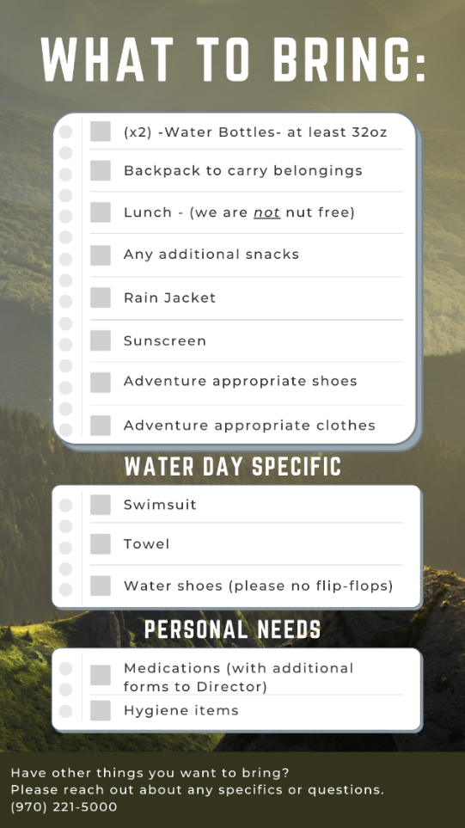
- Two weeks prior to your camp week you will receive a What to Expect email that will outline any changes to what they need to bring. For most programs over the summer, you can expect to bring the same items listed below:

